Shield Volcano  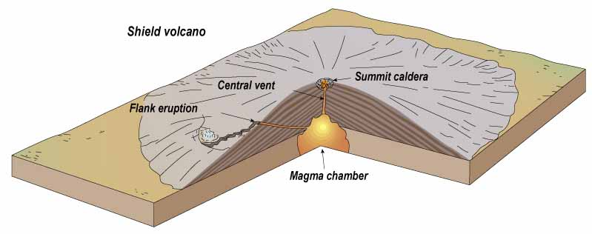 | Cinder cone  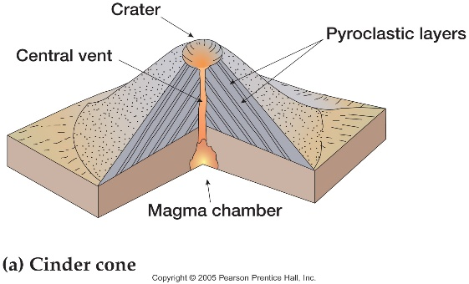 | Composite/Stratovolcano  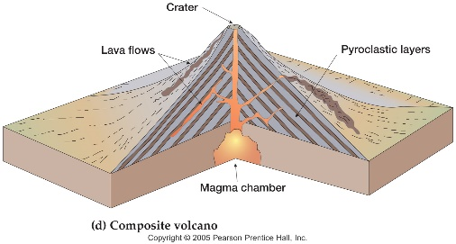
Shape:  - very broad,  - slight dome  Magma:  - hot, low viscosity  - high melting temp.  - (runny), fast moving  - Basaltic  Eruption Style:  - gentle, lots of magma.  Structure:  made from fluid basaltic lava  Gas:  - low levels  - can escape from magma  Example: Hawaiian Islands | Shape:  - small crater,  - steep sides,  - surrounded by small red or black basalt with little holes.  Magma:  - hot, low viscosity  - high melting temp.  - (runny), soft,  - Basaltic  Eruption Style:  - mildly explosive  - gas-filled lava cools to become cinders.  Structure:  made from fluid basaltic lava  Gas:  - high levels  - expands and forms bubbles in lava  Example: Sunset Crater, AZ | Shape:  - steep-sided cones  Magma:  - very viscous  - low melting temp.  - thick and sticky  - rhyolitic  Eruption Style:  - explosive, violent lava  - pyroclastic flows  - cinders, and ash clouds.  Structure:  made from layers of lava  rock and ash make it tall  Gas:  - high levels  - Pressure from gas bubbles trying to escape  Example: Mount Rainier

